Build And Publish Plugin POC

Prequisites 🡪

1)you should have Jenkins server up and running

2)cloudbees docker build and publish plugin should be installed

3)add line below in vi /etc/default/docker

DOCKER_OPTS="-H tcp://0.0.0.0:4243 --host=unix:///var/run/docker.sock --restart=false -g /opt/app/jenkins/docker -G jenkins"

Steps🡪

1. Create a freestyle job using git url as given below----

url =<https://github.com/manoj8928/EMS.git>

1. add a build step in the build step section,named as build/publish

The image is shared below-🡪

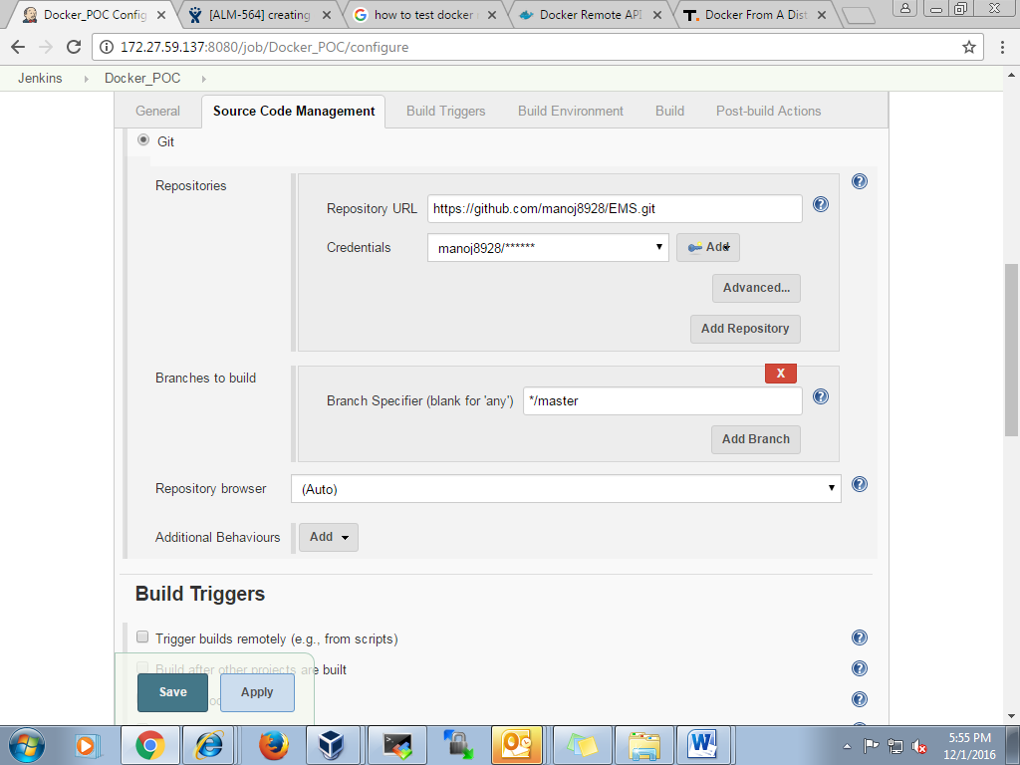

Build and publish plugin configuration 🡪

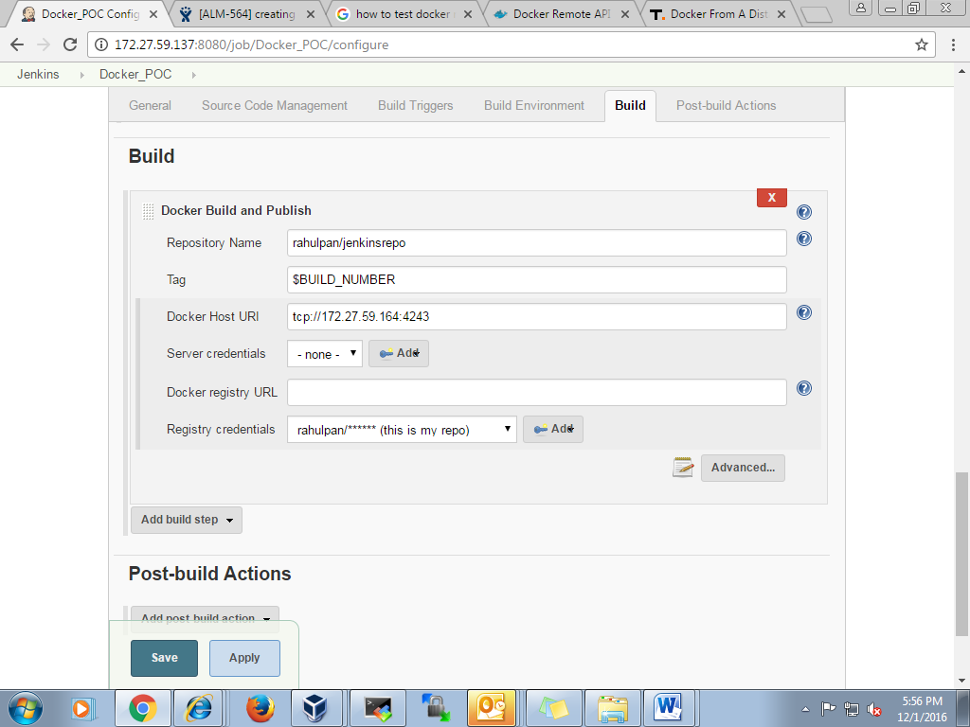

NOTE:make sure that the host on which you are building your job should contain docker daemon running.